Report on Assignment 5
Task 1
- Function of network: softmax(W_2 relu(W_1 input))
- Learning Rate: 0.5
- No of nodes in the hidden layer:100
The below graph shows the error rate and loss rate. The error rate is calculated using mean square error and the loss is calculated using softmax (T.nnet.categorical_crossentropy) for the train data. The weights are updated after 20epoches.
  - Fig 1.1 Error Rate
Fig 1.2 Loss Rate
The confusion matrix for the test data is as shown below.

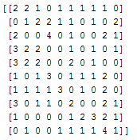
Fig 1.3 Confusion Matrix for test data

The matrix is plotted using plt.matshow and the figure is as shown below.
Fig 1.3 Confusion Matrix using matshow for test data

Task 2
- Function of network: softmax(W_2 sigmoid(W_1 input))
- Learning Rate: 0.5
- No of nodes in the hidden layer:100
The graphs below show the error and loss rate using sigmoid activation function in the first layer.
  - Fig 2.1 Error Rate
Fig 2.2 Loss Rate
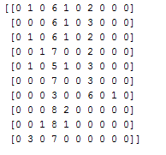
Fig 2.3 Confusion Matrix for test data
Fig 2.3 Confusion Matrix using matshow for test data

Task 3
- Function of network: softmax(W_2 relu(W_1 input))
- Learning Rate: 0.5
- No of nodes in the hidden layer:25,50,75,100,125

Fig 3.1 Error rate vs No of nodes in hidden Layer- run1
Fig 3.2 Error rate vs No of nodes in hidden Layer- run2

- Conclusion: The error rate is the least when the number of nodes in the hidden layer is 100

Task 4
- Function of network: softmax(W_2 relu(W_1 input))
- Learning Rate: 0.5
- No of nodes in the hidden layer:500
- Lamda=0.1

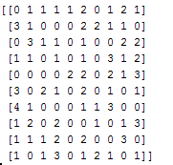
Fig 4.1 Confusion matrix for lamda 0.1

- Lamda=0.2
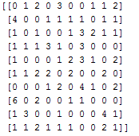
Fig 4.2 Confusion matrix for lamda 0.2

- Lamda=0.3
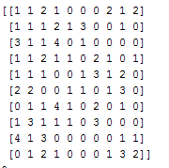 Fig 4.3 Confusion matrix for lamda 0.3

- Lamda=0.4
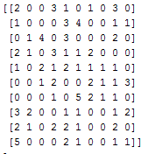 Fig 4.3Confusion matrix for lamda 0.Lamda=0.5
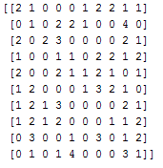
Fig 4.5Confusion matrix for lamda 0.5

- Conclusion: The confusion matrix shows accurate result upto an accuracy 30-40% when the lamda is 0.4

Task 5
The hyper-parameters that are chosen for the network are:-
- Function of network: softmax(W_2 relu(W_1 input))
- Learning Rate: 0.5
- No of nodes in the hidden layer:100 because the error rate is the least
- Lamda=0.4 to get an accuracy between 30-40% in classification
The loss and the error rate are as shown below.
  - Fig 5.1 Error Rate
  - Fig 5.2 loss Rate

The confusion matrix for the test data is as shown below.
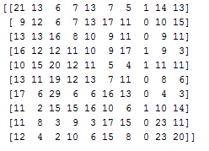
  - Fig 5.3Confusion Matrix

  - Fig 5.3Confusion Matrix using matshow

